A Dimensionality Reduction Approach to Modeling Protein Flexibility
Miguel L. Teodoro, George N. Phillips Jr and Lydia E. Kavraki

In Proceeding The Sixth Annual International Conference on
Research in Computational Molecular Biology RECOMB 2002
Abstract
Protein are involved either directly or indirectly in all biological processes in living organisms. It is now widely accepted that conformational changes of proteins can critically affect their ability to bind other molecules and that any progress in modeling protein motion and flexibility will contribute to the understanding of key biological functions. However, modeling protein flexibility has proven a very difficult task. This paper shows how to obtain a reduced basis representation of protein flexibility. We use the Principal Component Analysis method, a dimensionality reduction technique, to transform the original high dimensional representation protein motion into a lower dimensional representation that captures the dominant modes of motions of the protein.
- PCA of conformational data
In PCA, principal components are determined so that the 1st principal component 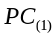 is aa linear combination of the initial variables 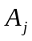, with j = 1,2,…,n. That is
where the weight 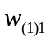,,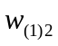,…, 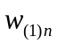 have been chosen to maximize the ratio of variance of to the total variation, under the constraint
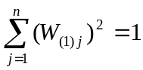

Created by : Chia-Chang Wang
Date : July 23, 2004
